**Manaswee Joshi**

1. Write a program that prints Hello World! to the console. Save the program as Hello.java.

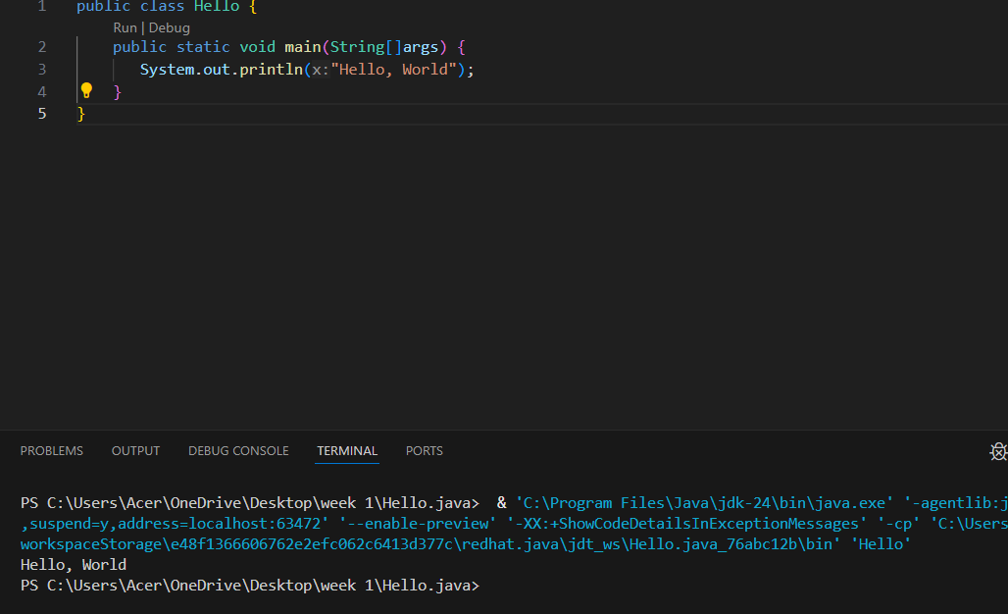

2. Extend/Modify the above program to print two additional lines:

This is my first program

I am on module ST4003CEM

System.out.print **(not println)** and produces the same output.

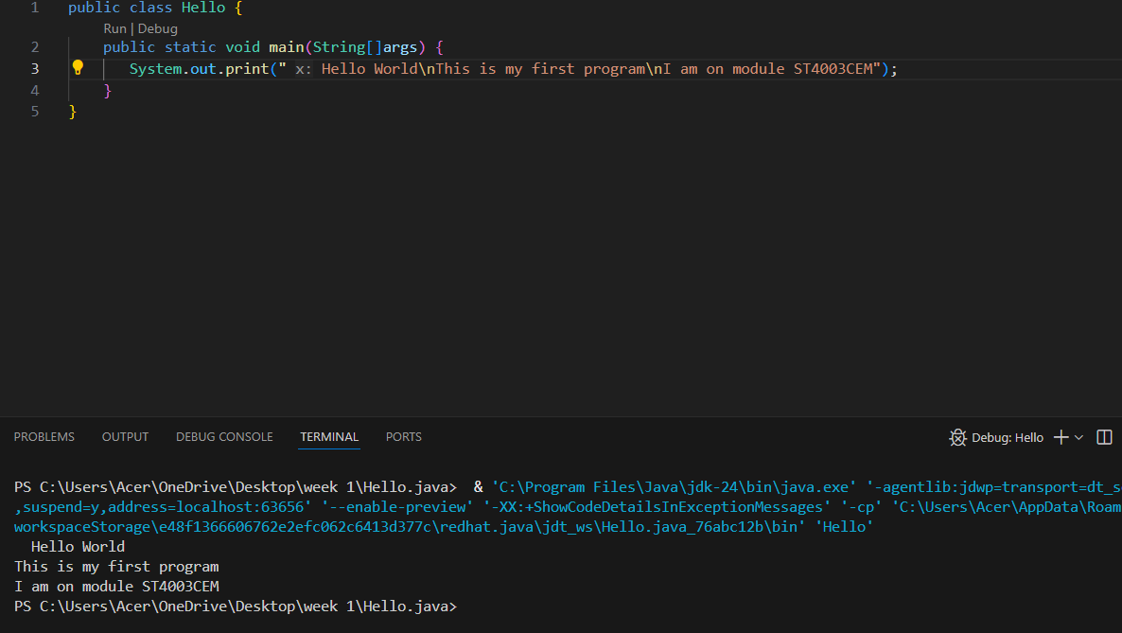

3. Write a program that prints the following output:

A "quoted" String is

'much' better if you learn

the rules of "escape sequences."

Also, "" represents an empty

String. Don't forget: use \"

instead of " !

'' is not the same as "

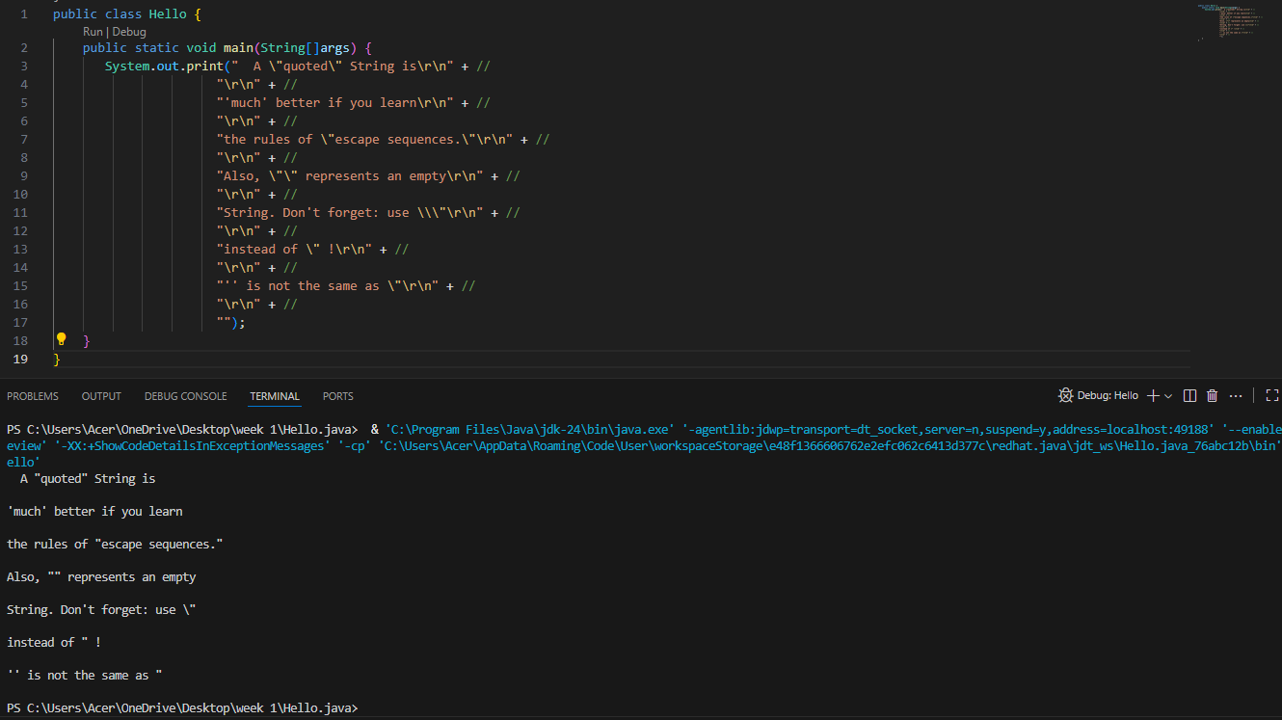

4. WAP that prints the following pattern:

*

**

***

****

**\*\*\*\*\***

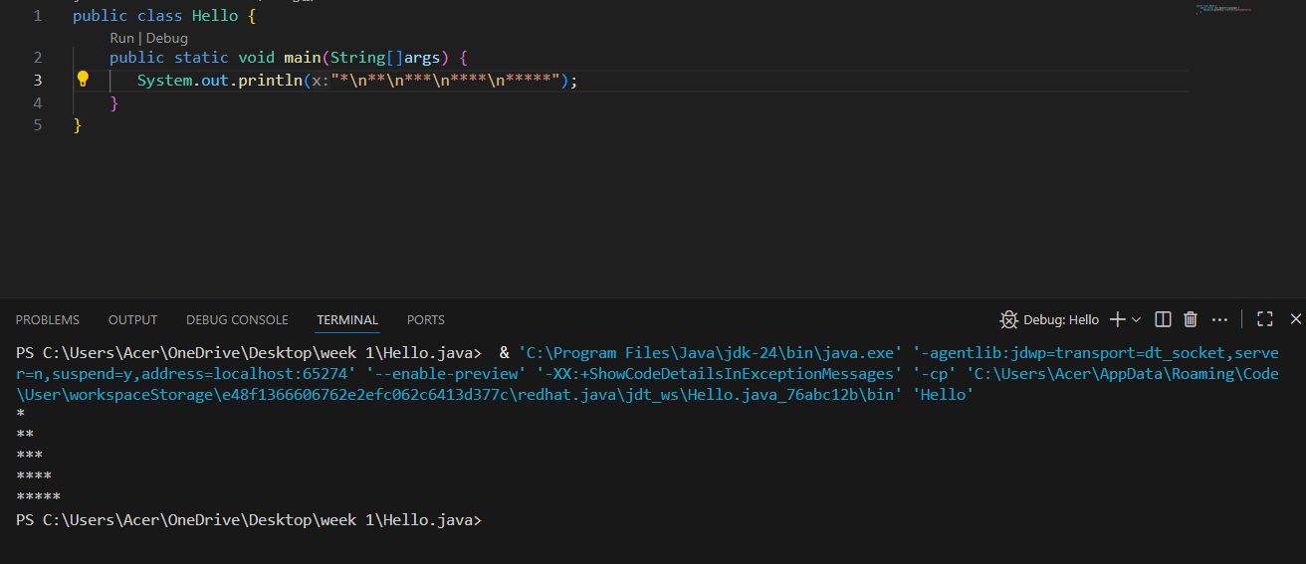

5. WAP prints the following pattern:

*********

*********

*********

*********

**\*\*\*\*\*\*\*\*\***

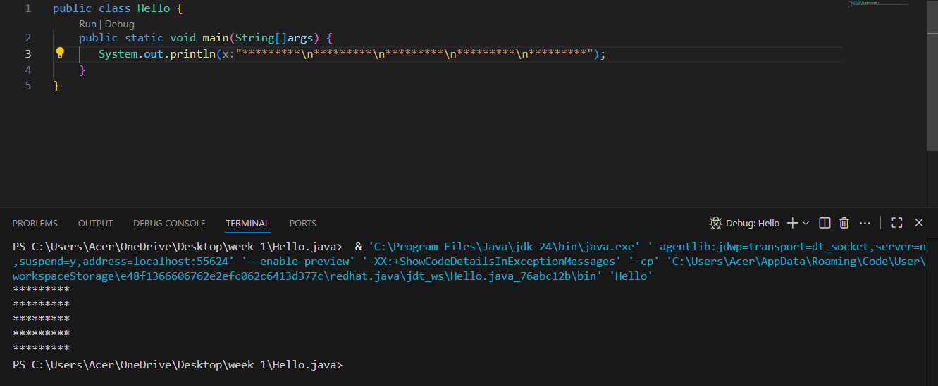

6. WAP that prints the following output:

A well-formed Java program has a main method with { and } braces.

A System.out.println statement has ( and ) and usually a String that starts and ends with a " character.

(But we type \" instead!)

What is the difference between

a ' and a "? Or between a " and a \"?

One is what we see when we're typing our program. The other is what appears on the "console."

